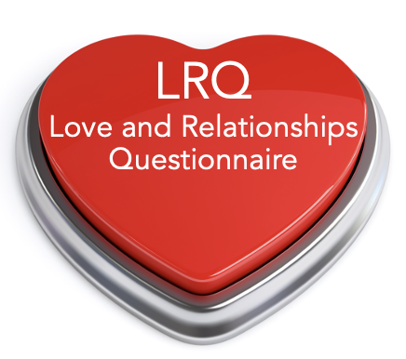
Workbook

By Dr. Corey Seemiller

This workbook is designed to accompany the LRQ (Love and Relationships Questionnaire). Complete this free inventory (https://rockthatrelationship.com/lrq/) and reflect on the questions in each chapter. When you are done, consider what you wrote, share your responses with others, or simply refer back to the tool in the future to see how you might have changed.

Disclaimer: This book is not intended as a substitute for consultation with a licensed mental health practitioner or medical doctor. Please consult with your own physician or healthcare specialist regarding any suggestions or recommendations made or implied in this book. The author of this book disclaims liability for any loss or damage suffered by any person as a result of the contents of this book.

©2025 by Corey Seemiller
All rights reserved. Unauthorized duplication is a violation of applicable law.
For more information, go to the author’s website at www.coreyseemiller.com.

General Reflection Questions


The following questions provide a foundation for the interpretation of your individual results of the LRQ and can be helpful to consider before diving deep into specific topics.
____________________________________________________________________________________

How often do you think about your views on love and relationships? Are these topics something you would normally reflect on or discuss with others? If not, why not?

Were there any questions on the LRQ that were more thought-provoking than others? If so, which ones, and what made them so thought-provoking?

What topics do you want to learn more about? Why those topics?

What did you find most insightful in completing the LRQ?

How can you use this insight to build and maintain healthy romantic relationships?

Demographics


Nationality


Where we come from often plays into our experiences and expectations of how we go about dating, falling in love, and getting into long-term relationships. Consider cultural norms, size of the community, religiosity, and opportunity for mobility as factors that all might influence one’s views on love.
____________________________________________________________________________________

List the places you have ties to in the table below.

Location
If you know your ancestry, where can you trace back your lineage?
Where were you born?
Where did you “grow up?”
Where do you currently live?
Where do you call “home?”

Do any of the places you identified have social norms or cultural expectations around love and relationships that are different from other places on your list? If so, what are those differences?

If you have lived in places with different social norms or cultural expectations around love and relationships, did you adapt to those new norms or expectations to better match those of your new location? If so, why? If not, why not?

How important is it/was it for you to end up in a marriage or long-term relationship with someone in a specific geographic community (where you currently live, hometown, big city, specific state or country, etc.)? Why that level of importance?

Generations
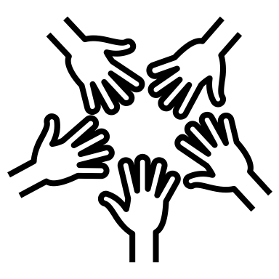

Generations are cohorts of people born during a particular birth range (typically within a 14-to 19-year time span). They share common experiences, beliefs, and perspectives, which are often shaped by the era in which they experienced adolescence and young adulthood. During this time, values are formed that can last a lifetime . . . and those can extend to how one views love and relationships.
____________________________________________________________________________________

What generation are you a member of?

- Silent/GI generation (1945 and earlier)
- Baby Boomer (1946-1964)
- Generation X (1965-1980)
- Millennial (1981-1994)
- Generation Z (1995-2010)

What are three key characteristics that would describe your generation.

1.

2.

3.

How might those characteristics play a role in how people in your generation might approach love and relationships?

Think of two innovations (technological, scientific, educational, etc.), two events (cultural, societal, global, etc.), and two social norms (expectations, ways of navigating life, etc.) that have most shaped how your generation views love and relationships.

How this has shaped how your generation views love and relationships
Innovation:
Innovation:
Event:
Event:
Social Norm:
Social Norm:

How do these views differ from those in other generations?

What is your perspective on dating or marrying someone when there is a significant age gap?

At what point is an age gap too big? Why would you say it is too big at that point?

Race

According to the International Encyclopedia of the Social & Behavioral Sciences (2nd edition), racial identity is comprised of several different components – self-consciousness (the strength of one’s racial group identification and how much a person likes being part of that group) and connection (the extent they feel interpersonally, emotionally, psychologically, and ideologically connected to the group). It’s easy to see then that one’s identity has the ability to shape perspectives on a variety of life experiences . . . including love.
____________________________________________________________________________________

How did you define your race in the LRQ?

- African-American or Black
- American Indian, Native American, or Alaska Native
- Asian-American or Asian
- Hispanic or Latino/a
- Middle Eastern
- Native Hawaiian or Other Pacific Islander
- White
- Other
- Prefer not to say

In your own words, describe your racial identity.

How does your racial identity impact the way you view love and relationships?

Are there stereotypes about your race that you have to contend with when it comes to love and relationships? If so, what are they?

How do you deal with those stereotypes?

What aspects of your racial identity do you feel give you a unique perspective on love and relationships?

Socioeconomic Status


Whether it’s the Beatles’ “Can’t Buy Me Love” or Blake Shelton’s “Minimum Wage,” songs about the intersection of love and money often capture the tension many people feel when considering and exploring romantic relationships.
____________________________________________________________________________________

To what extent does how you grew up economically impact your views on love and relationships today?

Has there ever been limitations on how you have approached dating and relationships because of money, or lack thereof?

Would you choose a near-perfect relationship with someone who could barely make ends meet or a content, but not completely fulfilling, relationship with someone who had great financial security (and possibly even substantial wealth)? Why?

Has the topic of money ever created conflict in a romantic relationship? If so, how?

Education Level


Education matters in dating and relationships…more so to people with higher credentials and those in younger generations, according to a study by Grand Canyon University. Some people want to be in a relationship with their educational equal, whereas others want to do so with someone who they consider their intellectual superior. Either way, education level is a factor many people place importance on in dating and relationships.
____________________________________________________________________________________

How important is it for you that your partner has attained a certain degree or educational credential?

Have you ever felt “less than” in a relationship because of your education level? “More than?” For either, what led you to feel that way?

Do you have preconceived notions about a potential partner based on their education level? If so, what are they?

What messages did you learn in your K-12 education that perpetuated unhealthy or unproductive stereotypes about dating? What about positive messages?

Gender Identity and Expression

One’s gender identity and the way they express that identity is rooted in perceptions of self, others, and relationship contexts and shaped and impacted by family, cultural, community, and societal expectations. Thus, the nature of gender can play a complex role in the perception of love and relationships.
____________________________________________________________________________________

In a few words, how would you describe your gender?

Is your description of your gender the same or different than it was earlier in your life? If it is different, what changed and why?

What expectations did you grow up with around gender (for instance, what messages were reinforced)?

How did those expectations influence how you see gender today?

What stereotypes exist around your gender when it comes to love and relationships? Do those stereotypes accurately reflect you?

List up to three things you do that challenge the stereotypes of your gender?

1.

2.

3.

Where did you learn to challenge those notions?

Do you believe in gender roles in relationships? Why or why not?

On the following continuum, mark with an X where you believe you fall in terms of gender.

Feminine-----------------------------Androgynous-------------------------Masculine

On the following continuum, mark with Xs where your previous partners have fallen in terms of gender.

Feminine-----------------------------Androgynous-------------------------Masculine

Do you have a typical type? If so, what do you think has been most influential in forging that pattern?

Sexual Orientation


Sexual orientation is the romantic, emotional, and/or sexual attraction patterns we have towards one or more specific genders. Given its clear influence on one’s perspectives and behaviors related to love and relationships, it’s critical to explore it further.
____________________________________________________________________________________

How would you identify your sexual orientation in your own words?

At what age did you realize your sexual orientation? What led you to affirm your orientation at that point in your life?

Have you ever been confused about your sexual orientation? If so, what was most confusing?

What types of messages were reinforced by your family growing up when it came to the concept of sexual orientation?

Considering how you identify in terms of sexual orientation today, what kinds of messages did you receive from people in the following contexts about that sexual orientation (even if then, your sexual orientation may have appeared differently to them)?

- Family:

- Friends:

- School:

- Place of Worship (if applicable):

- Community:

How has your sexual orientation impacted your view on dating and relationships?

Preferred Relationship Structure


Polyamory is engaging in romantic loving relationships with more than one person at a time, often through formalized partnerships. Ethical non-monogamy (ENM) is more of an umbrella term that involves being romantically or sexually involved with more than one person at a time but doesn’t always include partnership or love. Some people in marriages engage in ENM as a way to “open” their relationships so that each partner can explore romantic and/or sexual possibilities with others, often with high transparency and strict rules. Monogamy involves having a romantic and sexual relationship with only one person at a time. While it seems like there are so many options, finding what’s right for you is what’s most important.
____________________________________________________________________________________

How did you identify on the LRQ?
- Polyamorous
- Ethically non-monogamous (ENM)
- Monogamous
- Something else

Have you always identified that way? If so, why? If not, what changed?

Have you ever been curious about a relationship structure that is different from the one you identify with? If so, what piqued your curiosity? If not, what would it take to pique your curiosity?

How do you feel about dating someone who preferred a different relationship structure than you?

What about marrying someone with a different preference?

How does your preferred relationship structure impact your approach to love and relationships?

Relationship Status
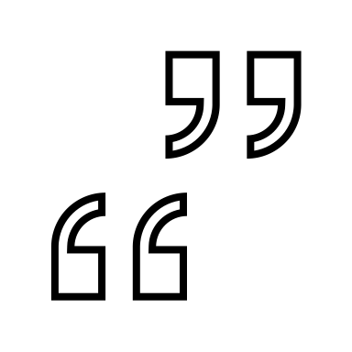

While not all, many people have had a string of relationships in their lives, perhaps ending in divorce, separation, and/or death of a partner. Some have never had a relationship, whereas others don’t intend to have one. Although you can fill in your relationship status on social media with only a few clicks, status is often far more complex and can play a role in how we view and pursue love and relationships.
____________________________________________________________________________________

If you indicated on the LRQ that you are separated, divorced, or widowed, how has that experience (those experiences) impacted your view of love and relationships moving forward?

If you have never been in a relationship, how does that affect your perspectives around love and relationships?

If you aren’t interested in pursuing a relationship, what are the reasons? Where did those reasons come from?

Parenting Role
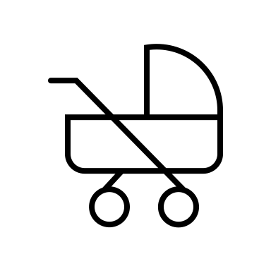

Having children is one of the biggest decisions one can make in their lives. Raising kids takes time, money, and a lot of love to parent well. Yet, most people are up for the occasion. According to Gallup, 9 in 10 adults either have children or want to have children. The parent-child relationship can certainly influence one’s perspectives on life and love, whether the messages we learn come from our parents or emerge as we learn to parent our own children.
____________________________________________________________________________________

If you are a parent, what made you decide to have children?

If you are not a parent, do you want kids? If you and your partner had different answers to this question, would that be a dealbreaker?

For those who are or have been parents, has your view on love and relationships changed since being a parent? If yes, how? If no, what do you think has caused it to stay the same?

How did your parents model love and relationships? How did their behaviors influence your view?

 | How they modeled | How that modeling influenced your view on love and relationships
Positively modeled
Positively modeled
Negatively modeled
Negatively modeled

If you are or want to be a parent, what are the three most important messages about love and relationships you would want to teach your children?

1.

2.

3.

Where did you learn those messages yourself?

Outlook


Religion and Spirituality


Religion is often thought of as a more formalized, structured set of beliefs in which there are texts, practices, expectations, and places of worship associated. Spirituality, on the other hand, is broader and involves connecting with a higher power through faith, meaning-making, and seeking purpose but typically doesn’t adhere to a system or structure that integrates specific practices for worship. And, those who don’t identify as religious or spiritual often have a set of beliefs about life that they have formed from their own experiences. Regardless of where they come from or what they are, people’s approach to relationships is often shaped by their strongly-held beliefs.
____________________________________________________________________________________

How would you define your religious/spiritual beliefs?

Where did those beliefs come from?

Have you ever doubted those beliefs? If so, why? If not, what kept you centered in your beliefs?

What most impacts your need to or desire to hold onto your specific beliefs?

When you shared on the LRQ about whether religion or spirituality impacts your perspectives on love and relationships, what was most surprising in your response?

Describe the three strongest religious or spiritual beliefs you have and the views on love and relationships shaped by those beliefs.

Religious or Spiritual Belief | Your view of love and relationships shaped by this belief

How important is it to you to partner with someone with similar religious/spiritual beliefs as you? Why?

Political Beliefs


Political ideology, for some, serves as a moral beacon with which they choose to live by. For others, it is a distant affiliation, if anything. Despite where one lies on the salience spectrum, most everyone can agree that politics drives our everyday lives. And, specific ideologies, beliefs, and even legislation have an impact on our choices as to how we experience love and relationships.
____________________________________________________________________________________

How significant is political ideology to your identity?

How might your political beliefs impact how you view love and relationships?

How have your political beliefs been shaped by your view on love and relationships?

Looking at the spectrum below, for up to five of your most significant partners you have had, put a check mark in the box of their political ideology at the time you were together.

 | Name: | Name: | Name: | Name: | Name:
Extreme Left (Anarchist, Communist, Socialist)
Far Left (Very Liberal or Progressive)
Left (Liberal, Democrat)
Center Left (Moderate Liberal)
Center-Fluid (Independent, Moderate on most issues)
Center-Blended (Liberal on some issues; Conservative on others)
Center Right (Moderate Conservative)
Right (Conservative, Republican)
Far Right (Federalist, Constitutionalist, Nationalist)
Extreme Right (Authoritarian)
No ideology
Libertarian
Other

How did their political ideology line up with yours and what was the impact of this alignment/misalignment on your relationship?

How important is having an aligned political ideology with your partner or spouse?

If it is important, list up to three political values/issues/beliefs that are “must haves” to be in alignment with you?

1.

2.

3.

Do you support finding a middle ground on any political issues with your partner? If so, what issues are you more likely to do that with?

Would you consider ending a relationship if your partner’s political beliefs changed? Why or why not?

Optimism


A Harvard study found that people who are optimistic live 11 to 15 percent longer, on average, than people who are not optimistic and actually have a greater likelihood of living past 85 years old. Countless other studies have found links between positivity and enhanced health, better responses to failure, and greater confidence. Being optimistic pays off! And, it can certainly impact the way people see love and relationships.
____________________________________________________________________________________

Looking at your scores for the LRQ, would you consider yourself optimistic? Why or why not?

How do your responses on the optimism scale fit with your views on love and relationships?

How your rating fits with your views on love and relationships
I am optimistic about my future.

I believe people are inherently good.

I believe good things will happen for me.

I plan for the worst-case scenario.

I assume others will let me down.

If you looked at these prompts and added “when it comes to my love life” to the end of each, would that change any of your ratings? If yes, how and why?

How in alignment does your partner need to be with you on the optimism scale? Why is this or is this not important to you?

Personality Type
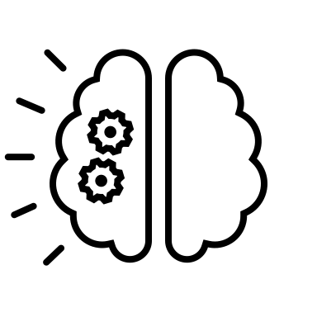

Personality type involves a complex classification system that categorizes people based on their perspectives and behavioral tendencies. While there are many personality type assessments available, one of the most well-known is the Myers-Briggs Type Indicator (MBTI), which measures one’s predispositions on four separate scales. In addition to the many professional uses of the MBTI, countless resources are available interpreting one’s MBTI results in the context of love and relationships.
____________________________________________________________________________________

In looking at each of the four MBTI scales, circle one of the two types you most resonate with. Then, for each, note the advantages and barriers of your type in regard to love and relationships.

 | Advantages | Barriers
Extraversion or Introversion
This scale measures where we get energy from. Introverts get energy from within themselves, process internally, and re-energize through solo endeavors, whereas Extroverts get energy from others, process externally, and re-energize by being around other people.

Sensing or Intuition
This scale measures how we take in information. Sensers like facts and data, are more present-oriented and concrete, and would rather do than think, whereas Intuitives like ideas and possibilities, are more abstract and future-oriented, and would rather think than do.

Thinking or Feeling
This scale measures how we make decisions. Thinkers are logical, objective, fair, and make decisions with their head, whereas Feelers take into account their personal feelings and circumstances, tend to be more subjective, and make decisions with their heart.

Judging or Perceiving
This scale measures how we interact with the outside world. Judgers are planned, organized, structured, scheduled, and like order, whereas Perceivers are spontaneous and flexible, go with the flow, and like to keep options open.

How can you leverage the advantages?

How can you overcome the barriers?

Have you ever been in a relationship with someone who was different from you on one of the scales? If so, what worked and what didn’t in that situation?

Are there some types you feel like you align with better when it comes to relationships? If so, which ones?

Family Dynamics


Family Structure
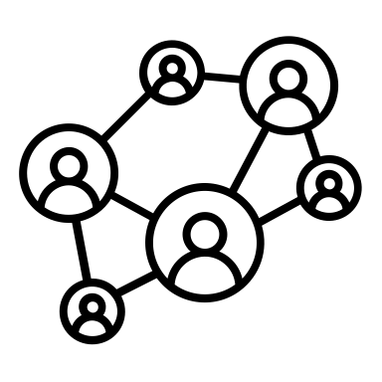

Today, people define family in multiple ways. Some kids are raised by biological parents, and others by adoptive parents, step-parents, or other family members or guardians. Children from divorced families may split their time between two households and need four tickets for all their parents to attend the school play. Other kids grow up in single-family homes, in multi-generational spaces, or in foster care. While no structure is inherently better than others, the way we experience familial relationships can shape the way we see all different types of relationships in our lives – romantic ones included.
____________________________________________________________________________________

In a few words, describe your upbringing in terms of your family structure.

What worked about your family structure?

What might have been challenging about it?

How do you think your family structure while growing up influenced the way you think about love and relationships today?

What is one message you could tell your 10-year-old self about love that you learned later on in life? Write it out as a letter to yourself.

Family Love Languages


Love Languages, a concept coined by author, Gary Chapman, helps us understand the way in which people prefer to receive love and appreciation. Sometimes, though, people give love and appreciation the way they like to receive it rather than the way the receiver wants to get it. This can create some disconnection, even though love is still at the center of the action. And, the way we received love from our families can influence how we hope to receive it in a romantic relationship.
____________________________________________________________________________________

What love language did your family express the most?

- Offered compliments, words of encouragement, and/or expressions of gratitude. WORDS OF AFFIRMATION
- Spent time with me, free from distractions. QUALITY TIME
- Helped me with a task or chore. ACTS OF SERVICE
- Gave me gifts or tokens of appreciation. GIFTS
- Was physically affectionate with me. PHYSICAL TOUCH

List three examples of how your family used that love language.

1.

2.

3.

Are there ways that your family didn’t show up that you would have liked? Why would that love language have been important to you?

Attachment Styles
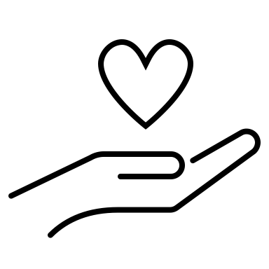

Psychologist, John Bowlby, is known for his seminal work in attachment theory. He asserts that people develop an attachment style that is shaped by their attachment experiences with their caregivers growing up. These styles then permeate into other relationships as adults, spurring people to act and react in ways that align with their styles.
____________________________________________________________________________________

Each response in the LRQ aligns with one of the four main attachment styles. Take a look at additional resources online about attachment styles to confirm if your response is reflective of your style.

- I deeply value relationships but have a fear of being abandoned or that my partner isn’t as invested as I am. Thus, I often need continued assurance from my partner. ANXIOUS
- I consider myself very independent and try not to depend on others. I can sometimes hide or suppress my feelings and tend to shy away from conflict. AVOIDANT
- I crave intimacy but sometimes push people away when I feel like they are getting too close. I sometimes struggle with identifying and expressing my emotions and avoid strong emotional attachments for fear of getting hurt. DISORGANIZED
- I can easily depend on my partner, and they can easily depend on me. I enjoy emotional closeness but can also fare well on my own. I can easily regulate my emotions and appropriately express them to my partner. SECURE

In what ways have you seen your attachment style at play in your love life?

If you are not securely attached, what are ways you can work towards that?

Dating
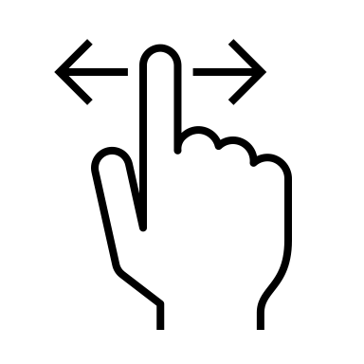

Perceptions of Dating


According to a Forbes Health/OnePoll survey on dating, 60 percent of active daters have an optimistic view of dating. The remaining 23 percent are indifferent, while 13 percent have a more negative view. With so many dating methods available to choose from, perhaps that positive outlook makes sense. Pick what works; leave what doesn’t.
____________________________________________________________________________________

Of the dating methods you indicated on the LRQ as being most effective, what makes them more effective?

Which of the dating methods would be least effective? What has shaped your opinion on this?

Of the dating methods you indicated as being most enjoyable, what makes them more enjoyable?

Which of the dating methods would be least enjoyable? What has shaped your opinion on this?

Is there a dating method you haven’t tried but would be curious if you are or were in the dating pool? Which one(s) and why?

Fears of Dating
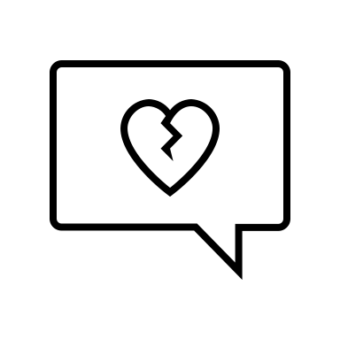

Whether it’s just first date jitters or full-blown sarmassaphobia (the fear of love play) or philophobia (the fear of falling in love), dating can be scary. While there are many ways to go about it, no matter if we peruse options online or get fixed up with a coworker’s friend, dating is still an act of vulnerability that takes a lot of thick skin and resilience. We put ourselves out there, take a chance with our hearts, and hope the person is the right fit. And, if they aren’t, it’s back to the drawing board.
____________________________________________________________________________________

Look at the biggest fears you indicated on the LRQ when it comes to dating. What has led you to fear those the most?

What other fears might you have about dating that weren’t listed on the LRQ?

Do you believe those are legitimate fears or are they more barriers you want to overcome? If they are legitimate, why do you believe so? If they are more barriers you want to overcome, what has led you to have those fears?

If you want to overcome any, how might you go about doing so?

Excitement Around Dating


While dating can be scary, it can also be fun, exciting, and invigorating. It gives us a chance to meet new people, go to new places, and explore possibilities of love. And, even in cases where there isn’t a romantic match, you might develop new interests and hobbies like entering into a new water color painting stint that arose after a “paint and sip” date. In the end, though, simply looking for love can be exciting, as it is a venture that can pay off for a lifetime.
____________________________________________________________________________________

Look at your responses in the LRQ about what excites you most about dating. What surprised you the most about your responses?

Are there other aspects of dating not listed in the LRQ that excite you? If so, what are they?

In what ways might these have changed over time, meaning what used to excite you doesn’t or what didn’t excite you now does?

If they have changed, what do you think influenced your opinion?

Turnoffs


Turnoffs are exactly that . . . behavior that immediately prompts an emotion or even visceral reaction when witnessed. Maybe your date was rude to the server, used profanity, talked about their ex, or simply didn’t text you back in a timely manner. Interestingly, research from Peter K. Jonason and associates found that dealbreakers (turnoffs) had a higher negative impact on a potential relationship than dealmakers (positive affirmations). So, even if your date were to be kind and have the same life goals, if they have bad hygiene, that might be the end of things.
____________________________________________________________________________________

What did you list as your biggest turnoffs? Why are those turnoffs for you?

What happens when you experience a turnoff – do you try to look past it, get the “ick,” call things off, etc.?

What do you do that might be a turnoff for others?

Relationship Expectations
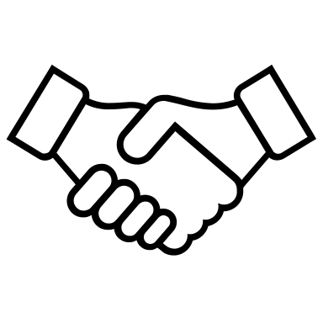

Relationship Attributes


When it comes to attributes we seek in a partner, sometimes we go for those that are similar to ours, like someone who is just as organized as we are. In other cases, we seek balance, like finding someone who is the calm to our chaos. Either way, it’s critical to know what we are looking for in love and relationships if we truly want to find it.
____________________________________________________________________________________

Of the 5 attributes you selected on the LRQ, which is the most important to you and why?

Are there attributes not on the list that you would deem very important to you? If so, what are they, and why are they so significant to you?

Are there attributes on the list that aren’t that important? If so, which ones are they and why are they less important?

What has influenced your opinion as to what attributes are the most significant?

Love Languages


Research has found that not only do partners with matching love languages tend to have higher relationship satisfaction, those who don’t but are aware of their partner’s love language do as well. Thus, knowing and showing love the way someone wants to receive it has great benefits for relationships.
____________________________________________________________________________________

What love language do you prefer the most? Why do you prefer that love language?

What are three examples someone could do to show love and appreciation for you using your love language.

1.

2.

3.

How important is your primary love language to you in relationships? Could you be okay if your partner never showed up with that love language?

How can you communicate to your partner (or future partner) about how to best leverage your love language?

How do you (or could you) show love and appreciation with a love language that doesn’t resonate with you but does for someone else?

Commitment


Reasons to Get Married


According to the Pew Research Center, 69 percent of unmarried 18- to 34-year-olds want to get married. But, people have a lot of different reasons for why they want to get married. For some, it may seem like the logical next step in adulthood, and for others, it may be the overwhelming urge to tie the knot with one’s true love.
____________________________________________________________________________________

For you, what would be (or was) the single most important reason to get married?

How have your worldviews or past experiences influenced the primary reasons you identified in the LRQ for getting married?

Are there items on the list that have no influence on whether you got married or not? If so, why wouldn’t they be on your list?

Reasons for Not Getting Married


A study by the Pew Research Center on what constitutes a fulfilling life found that only 23 percent of people thought that marriage was extremely or very important for having a fulfilling life, compared to 71 percent who indicated this for having a career they enjoy and 61 percent for having close friends. While marriage, in many ways, is seen as a rite of passage, its connection to a fulfilling life is certainly variable.
____________________________________________________________________________________

Are there reasons for not getting married that you think are so important that it would hold you up (or has held you up) from getting married? If so, what are they and why?

Are there reasons for not getting married that you think are impediments that you would like to overcome? If so, what are they and how could you overcome them?

Influences on Relationships


The earlier parts of our lives are heavily influenced by those around us – caregivers, parents, friends, and teachers. They help us create a blueprint for how we see love and relationships. Over time, this blueprint is confounded with messages we get as adults from personal experiences, values clarification, exposure to new perspectives, and the development of preferences. We try to muddle through the negative messages and capitalize on the positive ones – all leading us to refine how we see love and ultimately figure out what we want in a relationship.
____________________________________________________________________________________

Of the factors from your childhood or adolescence that were most influential in how you see relationships today, why would you say they had the impact they did?

Were there any items you marked on the LRQ as “would greatly influence” that you feel are non-negotiables for you?

Why are they non-negotiables?

Satisficing and Maximizing


Maximizers are those people who tend to search high and low for the ultimate partner. They will often not stop looking and will bypass good relationships in hopes of finding the ideal one. Satisficers, on the other hand, are those who create a list of attributes and once they find someone who meets their threshold, they partner up with them. In their minds, there is no further to look, as they have found their match. While research points to higher contentment among those who satisfice but more quality alternatives with maximizing, which approach is best is truly one’s personal preference.
____________________________________________________________________________________

Each response in the LRQ around maximizing and satisficing aligns with one of those two approaches. Take a look at additional resources online about maximizing and satisficing to find out more.

- When in a relationship, I often think the grass may be greener with someone else. MAXIMIZER
- When dating, I stop seeing other people and only pursue one as long as they seem like a viable option. SATISFICER
- When dating, I won’t stop until I find my ideal match. MAXIMIZER
- I seek a partner who generally meets my criteria knowing that doubts are normal in a relationship. SATISFICER
- I often find myself settling in relationships. SATISFICER
- When in relationships, I often question whether I am with the right person. MAXIMIZER

What might your responses tell you about your preferred approach?

List three experiences or instances where you saw your engagement in either maximizing or satisficing at play in your love life?

1.

2.

3.

How did those experiences turn out? Was your approach the best one for the situation?

Generally, are you happy with your approach (maximizing or satisficing)? If so, why? If not, why not?

Expressing Love


Crushes

Research has found that 8 in 10 people under the age of 20 have had a crush. Crushes, though, are not limited to those in adolescence and young adulthood; they can be prevalent with people across all age groups and even with those in committed relationships. Researchers from the Journal of Social and Personal Relationships found that the most common crushes involved classmates, friends, and coworkers. And, some were complete fantasy crushes that could never manifest. Regardless of who the crush is on and what the circumstance is, we can be sure that we’re not alone when it comes to experiencing unrequited love.
____________________________________________________________________________________

Are there some types of crushes that might be more harmful than others? If so, which ones and why? If not, why not?

How have you overcome crushes in the past?

What do your past patterns around crushes tell you about the way you perceive love and relationships?

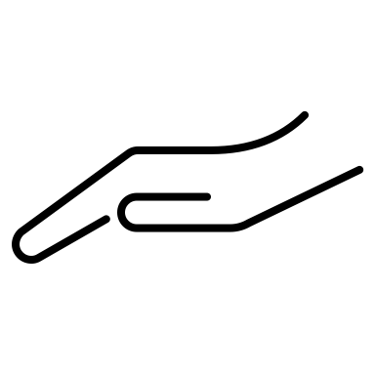
Soulmates
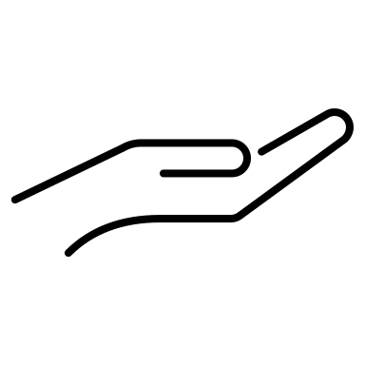

Sixty percent of American adults believe in soulmates, according to a poll by YouGov. And, 43 percent believe they are actually in a relationship with their soulmate. Whether from watching too many rom-coms or from one’s spiritual beliefs around the notion of destiny, soul compatibility is a goal for most people when it comes to looking for love.
____________________________________________________________________________________

Describe in a few words your opinion about soulmates?

How did you arrive at this opinion?

Have you ever held a different view about soulmates than you currently do? If so, what influenced the change?

Expressions of Love
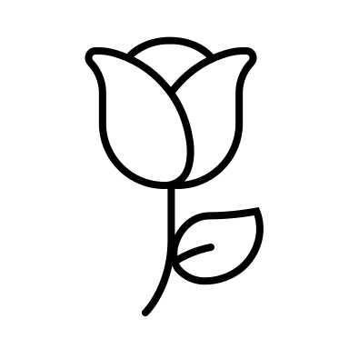

While we are taught to romanticize over-the-top gestures of love we see in the movies, those gestures don’t happen as frequently as Hollywood would have us think. More often, we fantasize about these things without acting on them. For instance, one study found that more than half of those who ended up getting divorced had imagined leaving their future spouse at the altar. However, hardly any do. And, in the case of this study, none of them did. Further, professing love to a crush or doing a public proposal usually doesn’t go well unless the other person has a heads up first. But, in some cases, we throw caution to the wind and take our chances . . . all in the name of love.
____________________________________________________________________________________

If you have ever initiated any of the actions listed on the LRQ, what compelled you to do so? What was the result?

Are there some actions on the LRQ list that you believe to be more acceptable than others? Why or why not?

Have you ever experienced (not initiated) any of these actions? If so, how did it feel? If not, how would it feel if someone did these actions towards you?

Relationship Maintenance
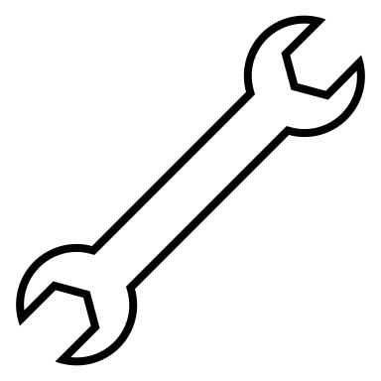

We often hear that “relationships take work.” But, we also hear that “if a relationship feels like too much work, it isn’t meant to be.” So, which is it? The authors of Secrets of Great Marriages say it’s a little of both. Relationships should be more work in the beginning until you figure out the kinks and develop the skills you need to effectively engage with your partner. But, with time and practice, things should get easier and more natural. It’s important to keep in mind, though, that relationship maintenance strategies that work for one couple might not for another. Just knowing what fits your situation is a skill that can be useful in fostering a healthy relationship for years to come.
____________________________________________________________________________________

In terms of the most effective behaviors for maintaining a relationship, what made you choose the ones on the LRQ you did?

Are there any behaviors that wouldn’t be effective at all (or might be least effective)? If so, which ones and why?

What personal experiences have led you to make these determinations about what is and is not effective?

Relationship Repair


Even with the best intentions, relationships can go south. And, often people who have put in a lot of time, effort, love, and energy aren’t ready to jump ship when trouble arises. Some stay months to try to work it out, whereas others might stay for years. While there are many ways to attempt to repair a relationship, one thing is for certain: without both partners being invested, repairing a relationship can be difficult.
____________________________________________________________________________________

In terms of the most effective behaviors for repairing a relationship, what made you choose the ones on the LRQ you did?

Are there any behaviors that wouldn’t be effective at all (or might be least effective)? If so, which ones and why?

What personal experiences have led you to make these determinations about what is and is not effective?

Love and Heartbreak
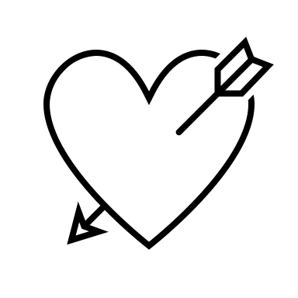

Definition of Love


Love is a complex construct with many definitions and nuances. Consider that the Oxford Dictionary alone has 24 different meanings for the word, “love.” Thus, defining it in a universal sense can be challenging. However, each person likely knows what love looks like and feels like to them. And, that definition can serve as a guiding beacon for how one navigates both their relationships and lives, in general.
____________________________________________________________________________________

If you could pull out three words from your definition of love that you think are the most important, what would they be?

1.

2.

3.

How do you think your definition of love has changed over time?

What has been most influential in shaping your definition of love?

Have you ever experienced your definition of love, exactly as it is written? If so, what did that experience feel like?

Been in Love
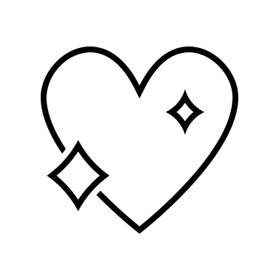

Being in love can spark feelings and even elicit behavior that might feel unrecognizable to some, especially those who haven’t been in love or at least haven’t been in a while. Although being in love can affect someone’s personal life, it can also have an impact on how that person shows up at work. For one, research has shown that experiencing new love can improve one’s attitude, productivity, and morale at work. In addition, it could create a dopamine boost that can spur an unparalleled sense of happiness, which could ignite collaboration and positive interactions with coworkers.
____________________________________________________________________________________

What does being in love feel like for you? How do you know when you are in love?

What has been the most exciting and the most challenging parts of navigating feelings of being in love while at work? Why?

When you have experienced any of these, how did you handle it?

Broken Heart
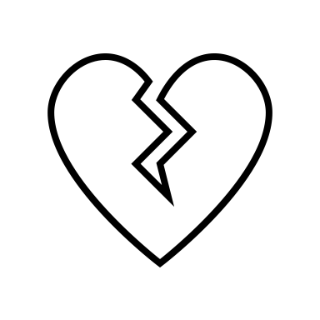

Researchers have found that 82 percent of people have experienced heartbreak. The main causes were breakup (41%), infidelity (27%), and rejection (15%). So, if you have ever struggled with a breakup, just note that you are not alone.
____________________________________________________________________________________

If you have experienced heartbreak, what three emotions have been most prevalent for you?

1.

2.

3.

If having had a broken heart has shaped the way you now view love, what about that experience (or those experiences) was most impactful in shaping your current perspectives?

If any of your heartbreak experiences have tainted your view on love, what could you do to overcome those negative views?

What has helped you in the past when healing a broken heart?

What hasn’t worked for you in healing a broken heart? Why?

Support


After experiencing a breakup, people seek support in many ways. A poll conducted by YouGov found that listening to music, throwing yourself into work, and calling someone to process the breakup are the most common strategies for dealing with heartache. And, if you wonder who that call would be to – most often it is to a friend, mom, or sibling. Rest assured, though, while some breakups can take years to heal from, research has found that most people overestimate how distressed they will continue to be after a breakup. So, keep up those healing strategies, and things will start to look up in no time.
____________________________________________________________________________________

Of all the things you need after a breakup, what would you say you need the most? Why that?

How do you go about getting the support you need?

Are there forms of support that people offer that you know you don’t need? If so, what are they and why don’t you feel you need them?

Breakup at Work


It’s clear that individuals’ romantic lives represent a significant aspect of their personhood—one that inevitably influences their experiences, relationships, and performance in the workplace. While some of the effects can be derived from positive experiences like being in the honeymoon stage of a new relationship or feeling the afterglow of a good date, dealing with heartbreak carries a heavier weight for many people. And, they carry that weight right into their workplaces.
______________________________________________________________________________

In terms of how you have dealt with a breakup at work, what was the most challenging? Why?

List the top three items from the LRQ list that you have found to be the most noticeable, intense, frequent, etc. when dealing with a breakup at work. Describe how you handled each.

How you experienced a breakup at work | How you handled that experience
1.

2.

3.

Closing Thoughts


The following questions help you weave together your insight from the previous topics.
____________________________________________________________________________________

What are the 3 biggest takeaways or learning moments you had in completing this workbook?

1.

2.

3.

What are 3 actions you plan to take in terms of your self-growth after completing this workbook?

1.

2.

3.

Write one statement which will serve as your “pep talk” for how you will commit to contributing to a healthy and productive relationship moving forward.

References

*References appear in order they are included in the workbook.

Broman, C. L. (2015). Race identity. International Encyclopedia of the Social and Behavioral Sciences (2nd ed.). Elselvier.

GCU Experience. (2021). Is education doing favors for your dating life? GCU. https://www.gcu.edu/blog/gcu-experience/education-and-relationships

Brenan, B. M. (2025). Americans’ preference for larger families highest since 1971. Gallup. https://news.gallup.com/poll/511238/americans-preference-larger-families-highest-1971.aspx

De Vivo, I. (2024). The new science of optimism and longevity. The MIT Press Reader. https://thereader.mitpress.mit.edu/the-new-science-of-optimism-and-longevity/

5 Love Languages. (n.d.). Relationships don’t have to be complicated. https://5lovelanguages.com

The Attachment Project. (n.d.). Bowlby and attachment theory: Insights and legacy. https://www.attachmentproject.com/attachment-theory/john-bowlby/

Prendergast, C. (2024). The state of dating in America in 2025: Emotional cheating ranks higher than physical cheating. Forbes Health. https://www.forbes.com/health/dating/state-of-dating

Karantzas, G. (2023). Is there science behind the five love languages? https://greatergood.berkeley.edu/article/item/is_there_science_behind_the_five_love_languages

Beshay. (2024). Among young adults without children, men are more likely than women to say they want to be parents someday. Pew Research Center. https://www.pewresearch.org/short-reads/2024/02/15/among-young-adults-without-children-men-are-more-likely-than-women-to-say-they-want-to-be-parents-someday

Greenwood, S., & Greenwood, S. (2025). What makes for a fulfilling life? Pew Research Center. https://www.pewresearch.org/social-trends/2023/09/14/what-makes-for-a-fulfilling-life/

Mikkelson, A. C., & Pauley, P. M. (2013). Maximizing relationship possibilities: Relational maximization in romantic relationships. The Journal of Social Psychology, 153(4), 467–485. https://doi.org/10.1080/00224545.2013.767776

O’Sullivan, L., & Belu, C. (2022). Loving you from afar: Attraction to others (“crushes”) among adults in exclusive relationships, communication, perceived outcomes, and expectations of future intimate involvement. Journal of Social and Personal Relationships, 39(2), 413-434.

Ballard, J. (2021). Do Americans believe in the idea of soulmates? YouGov. https://today.yougov.com/society/articles/34094-soulmates-poll-survey-data

Ballard, J. (2020). Most Americans believe in soulmates. YouGov. https://today.yougov.com/society/articles/27354-soulmates-relationships-poll-survey

Gander, K. (2015). Over half of divorcees had doubts on their wedding day and considered leaving their partner at the altar, study reveals. The Independent. https://www.the-independent.com/life-style/love-sex/marriage/over-half-of-divorcees-had-doubts-on-their-wedding-day-and-considered-leaving-their-partner-at-the-altar-study-reveals-10313378.html

Wanberg, C. R., Csillag, B., & Duffy, M. K. (2022). After the break-up: How divorcing affects individuals at work. Psychology of Employment and Personal Success, 1(1), 77-111.

Kawamichi, H., Sugawara, S., Hamano, Y. H., & Makita, K. (2016). Being in a romantic relationship is associated with reduced gray matter density in striatum and increased subjective happiness. Frontiers in Psychology, 7, 1763.

Emamzadeh, A. (2021). The many causes of heartbreak include breakups, infidelity, and rejection. Psychology Today. https://www.psychologytoday.com/us/blog/finding-a-new-home/202105/the-most-common-causes-of-heartbreak

Real Networks, Inc. (2015). Breakups are tough, but phone calls are easy: Americans still prove they're going steady with the phone call. https://www.prnewswire.com/news-releases/breakups-are-tough-but-phone-calls-are-easy-americans-still-prove-theyre-going-steady-with-the-phone-call-300031349.html

Eastwick, P. W., Finkel, E. J., Krishnamurti, T., & Loewenstein, G. (2007). Mispredicting distress following romantic breakup: Revealing the time course of the affective forecasting error. Journal of Experimental Social Psychology, 44(3), 800–807.

Levesque, D. A., Lunardini, M. M., Payne, E. L., & Callison-Burch, V. (2023). Grief in the workplace: Challenges and solutions. American Journal of Health Promotion, 37(3), 426-429.

Horan, S. M., Chory, R. M., Craw, E. S., & Mainiero, L. (2023). Workplace romance policies, behaviors, and reputational beliefs: Experiences of employees from major US cities. Communication Quarterly, 72(2), 121–147.

